27U ENCLOSURE 19" CABINET 600X600 FLOOR STANDING DATA RACK - ECO NETCAB
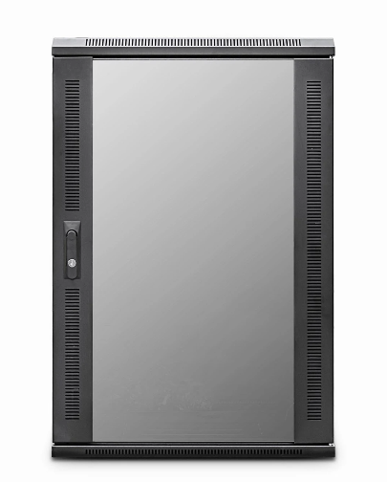

DESCRIPTION

Redefining quality ergonomics for your telco, networking & PBX needs
Cost-effective and quality enclosures for your structured cabling, networking and broadcast projects.
The LMS Data EcoNetCab is the defacto standard in offering great choice
and quality enclosure solutions, be it structured cabling for your copper or
fibre networking, LAN or WAN networking deployment or broadcast A/V for companies of all sizes.
Designed for the installer and IT manager, all enclosure come with useful
features to make your installation that much easier, together with bundled free
you need to get your new installation up an running, with minimal fuss or
downtime.

SPECIFICATIONS

27U high 600W 600D
ETSI 19” front/rear profiles (adjustable)
Removable side/rear panels, RAL 9005
Front tempered glass door (lockable)

TECHNICAL INFO
SKU/MPN: CAB-FE-27U-66
EAN: 8400800015952
Weight: 75kg
Dimensions: 600(width) x600(depth) x1370mm(height)

FILES
Datasheet - -CAB-FE-27U-66

